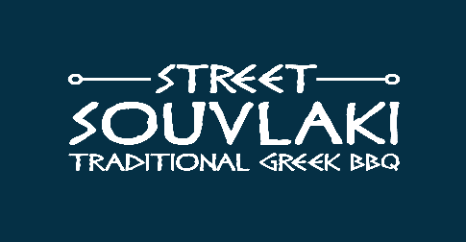
Games Expo
Menu
Marinated Chicken Souvlaki Kebab (Halal) £10
Chicken kebab skewers grilled over premium charcoal, served in warm Cyprus pitta bread with fresh salad (cucumber /tomato /red onion), homemade tzatziki sauce (Greek mint yogurt) & pickle chilli pepper
Allergens: Gluten (pitta bread), milk (yogurt)

Seasoned Pork Souvlaki Kebab £10
British pork kebab skewers grilled over premium charcoal, served in warm Cyprus pitta bread with fresh salad (cucumber /tomato /red onion), homemade tzatziki sauce (Greek mint yogurt), pickle chilli pepper & lemon wedge
Allergens: Gluten (pitta bread), milk (yogurt)

Grilled Halloumi Cheese Kebab (V) £10
Grilled Cypriot Halloumi cheese served in warm Cyprus pitta bread with fresh salad (cucumber/tomato/red onion), homemade tzatziki sauce (Greek mint yogurt) & pickle chilli pepper
Allergens: Gluten (pitta bread), milk (yogurt, halloumi)

Mix Souvlaki Kebab £12.5
Chicken & British Pork kebab skewers, Cyprus Halloumi cheese grilled over premium charcoal, served in warm Cyprus pitta with fresh salad (cucumber /tomato /red onion), homemade tzatziki sauce (Greek mint yogurt), pickle chilli pepper & lemon wedge Allergens: Gluten (pitta bread), milk (yogurt, halloumi)

Greek seasoned fries (GF) £4 Straight cut fries seasoned with Greek herbs and sea salt
Allergens: Soya

